YAC is a drug-free communities program and we are celebrating National Family day by paying for 110 people to participate in a free catered family dinner extravaganza. After dinner is the World Café. (Children under 12 will adjourn to games and fun activities.)
The World Café will mix health professionals and experts, local VIPs, and youth and their families in a meaningful conversation about community and family health, social norms, other related concerns and possible solutions. As a community leader, your assistance would be a meaningful contribution in this powerful and dynamic process.
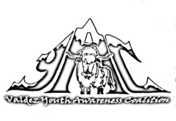
Please accept with RSVP
835-8922

